Unit 6 Assignment : Classification Using Decision Trees on Contraceptive Method Choice (cmc.csv)

DS Chin
University of Maryland Global Campus
Data 645
Dr. Firdu Bati
April 22, 2026

Introduction

Objective
The primary objective of this project is to determine the most effective decision tree-based modeling approach for the cmc.csv dataset. This analysis documents the progressive stages of model development, beginning with an initial classification tree fit to the entire dataset. The process then transitions into cost-complexity pruning to optimize tree depth, followed by the implementation of ensemble methods—specifically Random Forest and Boosting models—to maximize classification accuracy and minimize the deviance (log loss) score.

Problem Domain
Indonesia’s government viewed its rapid growth in population as an urgent matter affecting its economic stability and national development. The government needed to understand the reasons why Indonesian women were choosing (or not choosing) long-term contraceptive methods (like IUDs and tubal ligations), short term methods (like birth control pills and injections), or no methods at all. This survey took on an aggressive campaign to target women with field workers often being sent to villages to collect this information.

As a dominant Muslim-majority country (87%), Indonesia presented a significant case and drew substantial international interest from the rest of the world. Focusing on how religion may play a role in the women’s decisions, questions regarding religion, women’s education levels, and media exposure regarding these issues were variables included in this survey.

Method Rationale
The decision tree-based approach is uniquely suited for analyzing these types of datasets due to its ability to handle both categorical and numerical variables without requiring extensive feature scaling. Because the survey aims to understand complex behavioral choices, to include religious, educational, and social factors, the hierarchical nature of a decision tree mirrors the logical decision-making process an individual might follow when choosing a contraceptive method.
While a single decision tree offers high interpretability—allowing policy makers to visualize exactly which factors most influence contraceptive choice—it is often prone to overfitting. To address this, cost-complexity pruning is utilized to ensure the model generalizes well to predict outcomes in new data.
Furthermore, because demographic behavior is rarely driven by a single variable, ensemble methods like Random Forest and Boosting are employed. Random Forests reduce variance by aggregating multiple trees, which is essential for stabilizing predictions across diverse populations. Boosting, conversely, iteratively corrects the errors of previous trees, allowing the model to capture subtle patterns in the data that a single tree might miss. By optimizing for deviance and accuracy, this approach was taken to provide a robust tool for predicting population growth trends and informing national health strategies.
Analysis

Data
The cmc.csv dataset is a subset of the 1987 National Indonesia Contraceptive Prevalence Survey (NICPS), a landmark study conducted as part of the global Demographic and Health Surveys (DHS) program. While the original 1987 survey collected comprehensive data from nearly 12,000 women, this specific version was curated and donated to the scientific community by Tjen-Sien Lim in 1997. Currently, it is hosted on the UCI Machine Learning Repository, where it serves as a standard benchmark for academic and professional data science research, particularly in the evaluation of classification algorithms.

Exploratory Data Analysis (EDA)
The .shape, .info(), and .isna().sum() functions showed that this dataset consists of 1,473 observations across 10 variables with no missing values. While the .dtpes function showed that all variables were identified as int64 data types, a closer inspection of the attribute metadata reveals a more nuanced structure: two numerical variables, four categorical (ordinal) variables, three binary variables, and one multi-class target variable.

The following table outlines the variables, their descriptions, and their respective scales:

Variable Name | Description | Values / Scale
Wife's age | Numerical age in years | Continuous (16 – 49)
Wife's education | Education level of the wife | 1=Low, 2, 3, 4=High (Ordinal)
Husband's education | Education level of the husband | 1=Low, 2, 3, 4=High (Ordinal)
Number of children | Number of children ever born | Numerical (0 – 16)
Wife's religion | Whether the wife is Muslim | 0=Non-Islam, 1=Islam (Binary)
Wife now working? | Current employment status | 0=Yes, 1=No (Binary)
Husband's occupation | Occupational category | 1, 2, 3, 4 (Categorical)
Standard-of-living | Standard-of-living index | 1=Low, 2, 3, 4=High (Ordinal)
Media exposure | Exposure to mass media | 0=Good, 1=Not good (Binary)
Contraceptive method | Target variable | 1=No-use, 2=Long-term, 3=Short-term

It was necessary to change the eight categorical variables from int64 to category using the loop function (Code 1) as this would allow the ModelSpec (MS) function to properly analyze the data. Additionally, a dictionary (Code 2) was formulated with a descriptive label of the categories for easy and quick interpretation.

Three sets of visualizations were created to highlight the bigger picture of each variable and display nuanced information not always achieved through just through the numbers from the .decribe function:

- Histograms (Figure 1) and Boxplots (Figure 2) were made to display the continuous variables WifeAge and NumChildren
- Pie Charts (Figure 3) were made to display the rest of the 8 categorical variables

The visualizations highlighted in the WifeAge variable that the majority of women were between the ages of 25 and 38 with youngest being 16 and oldest at 48. The vast majority of these women had 1 to 4 children with a good amount having up to 8 children; the highest children count was 16.

The pie chart demonstrated a good general finding of the socio-economic and demographic profile of the participants. The data shows that a vast majority of the women are Muslim and that a significant portion are not currently working. Education levels for both wives and husbands lean towards the "medium high" and "high" categories, suggesting a relatively educated sample. The standard of living is predominantly reported as "high" or "medium high," and media exposure is overwhelmingly categorized as "good". In terms of the target variable, "no use" of contraceptive methods is the most frequent choice, followed by "short term" methods, with "long term" methods being the least common.

Preprocessing and Algorithm Intuition
In classification trees, the need for explicit manual preprocessing is minimal due to the specialized functions and algorithms utilized in the development process. Specifically, the ModelSpec (MS) function, DecisionTreeClassifier (DTC), and GridSearchCV effectively automate many of the traditional data preparation steps. This efficiency allows for a more direct transition from data exploration to model implementation without the intensive feature engineering often required by other models. One of the primary advantages of this approach is the seamless handling of qualitative predictors. Unlike many classical statistical methods that require the manual creation of dummy variables or one-hot encoding, decision trees can naturally incorporate qualitative predictors into their architecture. The ModelSpec function facilitates this by setting up the model matrix, while the tree-building process itself handles categorical splits by assigning specific levels to different branches. Furthermore, decision trees exhibit a high degree of scale independence. Because the model uses a greedy approach to identify the best cutpoint for each variable independently, it is not sensitive to the scale of the predictors; consequently, standard procedures such as feature scaling or normalization are not necessary.
The core intuition of the decision tree algorithm lies in its "divide and conquer" logic, which seeks to partition the feature space into distinct, non-overlapping regions. The fundamental principle is to make the resulting child nodes as "pure" as possible. In this specific analysis, the algorithm employs ‘entropy’ as the criterion for measurement, a concept rooted in information theory that quantifies the uncertainty or "impurity" within a node. Entropy (D) is defined by the equation D=−∑k=1K​p^​mk​logp^​mk​, where p^​mk​ represents the proportion of training observations in the mth region belonging to the kth class. By utilizing entropy, the tree performs splits that maximize "Information Gain"—the difference between the entropy of a parent node and the weighted sum of its children's entropy. This guides the model to make partitions that result in the greatest increase in order and classification certainty.

Model Fitting
The model fitting process for this analysis follows a structured progression from a foundational classification tree to advanced ensemble techniques, systematically refining the model to balance interpretability with predictive power.

Initial Model Fitting
The process of fitting the initial model centers on establishing a baseline using a single, interpretable decision tree. In this stage, the full dataset is passed through a classification algorithm that utilizes the entropy criterion to determine how to partition the data. Entropy serves as a measure of "impurity"; the algorithm searches for the specific socio-economic features and threshold values that most effectively split the Indonesian survey respondents into groups with more uniform contraceptive choices.
To ensure the resulting tree remains a useful diagnostic tool, the fitting process is intentionally constrained with a maximum depth limit (3 in this case). This prevents the model from growing an overly complex "forest" of branches that might capture coincidental noise or outliers within the data. By limiting the depth, the fitting process forces the model to prioritize only the most dominant predictors—such as age and the number of children—which are the primary drivers of decision-making in the dataset.
This initial fitting stage is not designed to produce a final predictive tool, but rather to reveal the foundational "logic" of the dataset. It allows for the visualization of the primary decision paths, providing a clear map of how the most influential variables interact before any pruning or ensemble techniques are applied to refine the boundaries. This baseline is essential for understanding where a simple logical structure succeeds and where it begins to struggle with overlapping categories, justifying the transition to more advanced modeling phases.

Cost-Complexity Pruning
To address the limitations of the initial model, the process transitions to cost-complexity pruning. The core reason for pruning is to reduce the complexity of the tree to ensure it generalizes well to unseen data. This is achieved by utilizing GridSearchCV to tune the ccp_alpha (complexity parameter). This parameter adds a penalty for each additional leaf node, effectively "cutting back" branches that do not provide significant predictive value. While this modification might slightly lower the training accuracy score, the goal is to improve the model's stability. By selecting an optimal subtree through cross-validation, we observe a refinement in the deviance score, indicating a more robust model that avoids the pitfalls of overfitting while maintaining the decision tree's core logic.

Ensemble Methods: Random Forest
The model fitting process is further optimized by implementing a Random Forest approach. Random Forest improves upon a single pruned tree by building an ensemble of multiple decision trees, each trained on a different bootstrap sample of the data. Furthermore, at each split, the algorithm only considers a random subset of the predictors, which de-correlates the trees. This technique can significantly enhance the accuracy score by reducing variance—the tendency of a single tree to fluctuate wildly based on small changes in the data. The resulting deviance score typically improves because the aggregated predictions of many trees are more reliable than those of any single tree, providing a more stable reflection of population-level behavior.

Sequential Optimization: Boosting
Finally, the process concludes with Gradient Boosting, which takes a fundamentally different approach than the previous methods. While Random Forest builds trees in parallel and averages them, Boosting builds trees sequentially. Each subsequent tree is grown specifically to correct the errors (residuals) made by the previous trees. This iterative learning process focuses the model's attention on the "hard" cases in the dataset—those specific demographic profiles where contraceptive choice is most difficult to predict. This targeted optimization allows Boosting to capture subtle, high-dimensional interactions between variables that both single trees and Random Forests might miss. By tuning hyperparameters like learning_rate and n_estimators, the boosting model seeks to achieve the lowest possible deviance, representing the peak of the model's predictive capability in this analysis.

Results

Output
The models successfully identified non-linear patterns, revealing that a woman’s choice is not driven by a single factor but by the interaction of several variables. However, a significant finding in the output is that all models encountered difficulty when attempting to predict the "Long-term" contraceptive category. In the confusion matrices across all stages, this class suffered from consistent misclassification, as the profiles for long-term users frequently mirrored those of short-term users. Thus the progression of the models reveals a nuanced trade-off between accuracy and deviance (log loss). While accuracy scores remained relatively flat, the manner at which these models seemed to reach their conclusions—and their "confidence" in those conclusions—changed.

Model Properties and Evaluation

Initial Model
The initial baseline model achieved an accuracy of approximately 53.97%, coupled with a residual deviance of 0.9236 (Figure 9). While these figures suggest a reasonably strong fit to the data, their significance is heavily tempered by the fact that the model was evaluated on the same data used for training.
In this specific setup, the accuracy reflects the model's ability to "memorize" the logic of the Indonesian survey results rather than its ability to predict the behavior of new, unseen populations. Similarly, the residual deviance indicates how well the model’s probabilistic predictions aligned with the training observations; a value of 0.9236 establishes the benchmark for uncertainty that the subsequent ensemble models will aim to reduce.

Pruned Model
To address the limitations of the initial baseline, this model implements a more rigorous validation framework through a 50/50 train-test split and Cost-Complexity Pruning (CCP). This stage represents a critical transition from "memorizing" data to "generalizing" patterns. The primary objective of pruning is to manage the bias-variance trade-off; an unpruned tree often becomes overly complex, capturing "noise" or coincidental patterns in the training set that do not exist in the broader population. By utilizing GridSearchCV to identify the optimal complexity parameter (ccp_alpha), branches with minimal predictive power were removed. This structural refinement resulted in a smaller, more robust tree that identifies definitive predictors—such as childlessness being a primary indicator for contraceptive non-use—while simplifying other classifications through key thresholds in age and education.
The model yielded a Pruned Tree Test Accuracy of 0.5319. While this figure remains stable compared to the initial baseline, its value is significantly more robust because it was achieved on a test set the model had never encountered. This confirms that the decision rules are not merely artifacts of the training data but are generalizable to the broader dataset. However, the Pruned Tree Deviance (Log Loss) of 1.1381 is a critical metric for this evaluation (Figure 10). A log loss above 1.0 indicates that while the model is selecting the correct labels over half the time, it is doing so with a high degree of probabilistic uncertainty. The model is essentially "hedging its bets" between categories, which is expected given the significant demographic overlap in the Indonesian survey data.
Despite the optimization achieved through pruning, the confusion matrix highlights (Figure 4) a persistent difficulty in accurately identifying the "Long-term" contraceptive category. This challenge stems from significant demographic overlap and class imbalances, as the profiles of long-term users often mirror those of short-term users or non-users. Consequently, the tree logic remains conservative, frequently defaulting to the more numerically dominant "Short-term" or "No-use" categories unless indicators such as high education and parity are exceptionally strong. This results in the "Long-term" class being consistently under-represented, providing clear evidence that a single optimized tree is insufficient for capturing the high-dimensional interactions present in this population.

Random Forest Model
The transition to a Random Forest model represents a shift toward an ensemble-based approach designed to overcome the high variance and limited predictive scope of a single decision tree. By training 200 independent trees on various bootstrap samples of the data, the model utilizes "bagging" and feature randomness to ensure that no single outlier or dominant variable skews the results. A key structural enhancement in this model is the introduction of the Age_Children_Interaction variable (Code 3), which attempts to improve the ensemble's ability to navigate the complex relationship between a woman's life stage and her reproductive choices.

The model (Figure 7) achieved a test accuracy of 53.46%, the highest among the tree-based methods evaluated, with a log loss deviance of 0.9297. The feature importance analysis highlights that the interaction between age and the number of children (0.264) is the single most influential predictor, followed closely by age (0.213) and parity (0.160). By aggregating the "votes" of hundreds of trees, the Random Forest achieved better stability than the pruned tree, particularly in the socio-economic "middle grounds." This ensemble approach seems to allow the model to leverage secondary factors like education and living standards more effectively, providing a more comprehensive view of the determinants behind contraceptive use.

Despite these gains, the confusion matrix reveals that the Random Forest still faced difficulty with the "Long-term" contraceptive category (Figure 5). To accommodate this, the model utilized balanced class weights, which forced the algorithm to pay more attention to the less frequent categories. This structural adjustment helped "smooth out" the classification errors across the board, ensuring that the model didn't simply ignore the long-term users in favor of more common outcomes. While the overall accuracy reflects the difficult nature of this three-class classification problem, the Random Forest stands out as the most reliable tool for identifying the primary drivers of contraceptive behavior while maintaining the best performance on unseen data.

Gradient Boosting Ensemble Model

The final stage of the modeling process utilized a Gradient Boosting Classifier, which represents the most sophisticated approach to meeting the project’s predictive objectives. Unlike the Random Forest, which builds trees in parallel, Gradient Boosting operates sequentially. Each subsequent tree is specifically designed to minimize the residual errors (deviance) of the preceding trees. By focusing on these "residuals," the model systematically reduces the uncertainty in its predictions, making it an ideal choice for the highly nuanced and overlapping demographic data found in the Indonesian contraceptive survey.

The Boosting model achieved a test accuracy of 52.24% and a log loss deviance of 0.9567 (Figure 8). While the raw accuracy is slightly lower than the Random Forest, the boosting model’s structural property of sequential optimization allows it to prioritize high-dimensional interactions. This is evidenced by the dominance of the Age_Children_Interaction variable, which carries an importance weight of 0.3914—the highest influence seen in any model. This confirms that for boosting, the combined effect of a woman's age and her parity is nearly twice as important as any other single socio-economic factor in determining contraceptive behavior.

A critical characteristic of the boosting model is its aggressive attempt to resolve the classification issues surrounding the "Long-term" contraceptive category. In the confusion matrix (Figure 6), the model displays a targeted effort to isolate these cases by penalizing misclassifications more heavily as the iterations progressed. By tuning hyperparameters such as learning_rate and subsample, the model sought to find a balance where it could capture these subtle behavioral signals without overfitting to the training data. This makes the boosting results particularly valuable for health policy, as it highlights the demographic segments where behavior is most difficult to predict, providing a clear map of where additional data or specialized intervention may be required.

Conclusion

Summary
The concluding summary of this study highlights the complex nature of predicting contraceptive behavior and the varying effectiveness of different tree-based modeling architectures. The primary finding is that while each model—ranging from simple decision trees to sophisticated ensembles like Random Forest and Gradient Boosting—demonstrated unique structural strengths, no single approach was able to fully overcome the challenge of accurately distinguishing long-term contraceptive users from other demographic groups.
The analysis revealed that contraceptive choice is driven by high-dimensional interactions rather than isolated variables. Specifically, the relationship between a woman's age and her total number of children emerged as the most critical predictor across all frameworks. Simple trees provided a clear, interpretable roadmap of these primary drivers, but they proved too rigid to handle the nuances of the data. While the ensemble models offered greater stability and a more comprehensive view of secondary factors like education and living standards, the persistent overlap in the demographic profiles of different user groups meant that predictive gains remained incremental.
Ultimately, the study confirms that the "Long-term" contraceptive category remains the most difficult to isolate, regardless of the model's sophistication. These findings suggest that while tree-based models are powerful tools for identifying broad behavioral trends and key socio-economic drivers, the significant overlap between contraceptive choices in this population may require additional qualitative data or alternative modeling strategies to achieve higher precision in identifying long-term family planning needs.

Limitations and Improvement Areas
From an algorithmic standpoint, a notable limitation was the inability to incorporate Bayesian Additive Regression Trees (BART) into the study. While BART is a powerful "sum-of-trees" model known for its ability to capture complex interactions and provide uncertainty intervals, the standard implementation available for this analysis was restricted to binary target variables. Given that the Indonesian contraceptive study involves a multi-class (multivariate) target—"No-use," "Long-term," and "Short-term"—the existing technical framework could not accommodate the data without a complex re-engineering of the target variable into a binary format. Lacking the specific domain knowledge to transform this multivariate problem into a series of binary classification tasks without losing critical categorical information represented a significant hurdle for the current analysis.

A personal area for improvement would be the implementation of a multi-class BART model or the manual conversion of the target variable using "One-vs-Rest" strategies. BART would have been particularly interesting for this dataset because it treats each tree as a "weak learner" that contributes only a small piece to the final prediction, often yielding better generalization than Random Forest or Boosting on noisy socio-economic data. Furthermore, BART’s Bayesian framework would provide a "posterior distribution" for each prediction, allowing researchers to quantify exactly how uncertain the model is when it encounters a woman in a demographic "middle ground."
Beyond algorithmic expansion, incorporating more recent data or additional features could help resolve the class overlap issues. Features related to regional healthcare access, proximity to clinics, or qualitative data regarding cultural attitudes toward specific methods might provide the missing links needed to distinguish "Short-term" from "Long-term" users. By combining these expanded datasets with advanced Bayesian methods, future models could move beyond the accuracy plateaus encountered in this study and provide more precise, probabilistic tools for national health planning.

REFERENCES:

Central Bureau of Statistics (CBS) [Indonesia], National Family Planning Coordinating Board (NFPCB) [Indonesia], Ministry of Health (MOH) [Indonesia], & Institute for Resource Development (IRD)/Westinghouse. (1987). Indonesia Contraceptive Prevalence Survey 1987. DHS Program. https://dhsprogram.com/publications/publication-fr19-dhs-final-reports.cfm

Lim, T.-S., Loh, W.-Y., & Shih, Y.-S. (1987). Contraceptive Method Choice [Dataset]. UCI Machine Learning Repository. https://archive.ics.uci.edu/dataset/30/contraceptive+method+choice

Stanford Online. (2022, October 7). Statistical learning: 8.1 tree based methods [Video]. YouTube. https://www.youtube.com/watch?v=QNnayf--_yk

Stanford Online. (2022, October 7). Statistical learning: 8.2 more details on trees [Video]. YouTube. https://www.youtube.com/watch?v=JaoTOfTNOVk

James, G., Witten, D., Hastie, T., Tibshirani, R., & Taylor, J. (2023). Tree-based methods. In An introduction to statistical learning with applications in Python (pp. 311–352). Springer. https://hastie.su.domains/ISLP/ISLP_website.pdf

Google. (2024). Gemini (March 2024 version) [Large language model]. https://gemini.google.com/ (for assistance with coding help and writing this report)

CODES
Code 1
qual_cols = ['WifeEducation', 'HusbandEducation', 'WifeReligion',
'WifeWorking', 'HusbandOccupation', 'LivingStandardIndex', 'MediaExposure',
'ContraceptiveMethod']

for col in qual_cols:
cmc[col] = cmc[col].astype('category')

Code 2
mappings = {
'WifeEducation':{1:'low', 2:'medium low', 3:'medium high', 4:'high'},
'HusbandEducation':{1:'low', 2:'medium low', 3:'medium high', 4:'high'},
'WifeReligion':{0:'Non-Islam', 1:'Islam'},
'WifeWorking':{0:'Yes', 1:'No'},
'HusbandOccupation':{1:'low', 2:'medium low', 3:'medium high', 4:'high'},
'LivingStandardIndex':{1:'low', 2:'medium low', 3:'medium high', 4:'high'},
'MediaExposure':{0:'good', 1:'not good'},
}
target_mapping = {1:'no use', 2:'long term', 3:'short term'}

Code 3

FIGURES
Figure 1
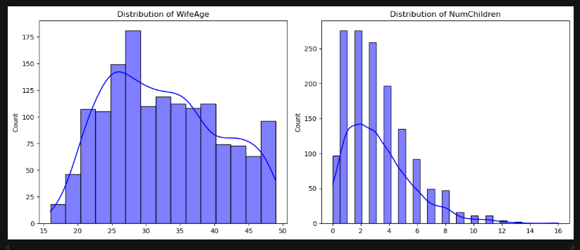

Figure 2
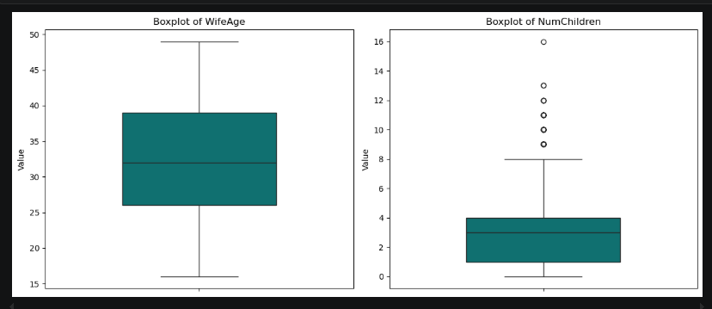

Figure 3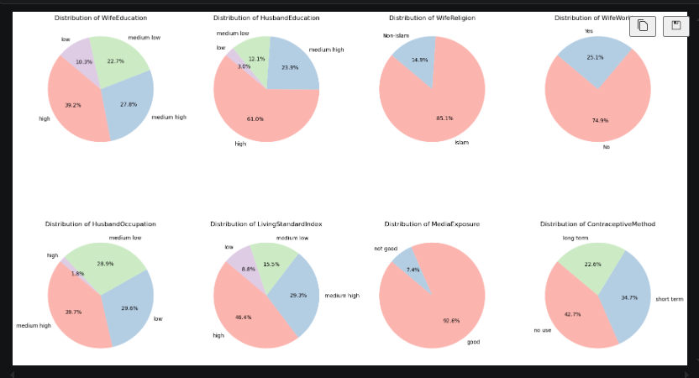
Figure 4
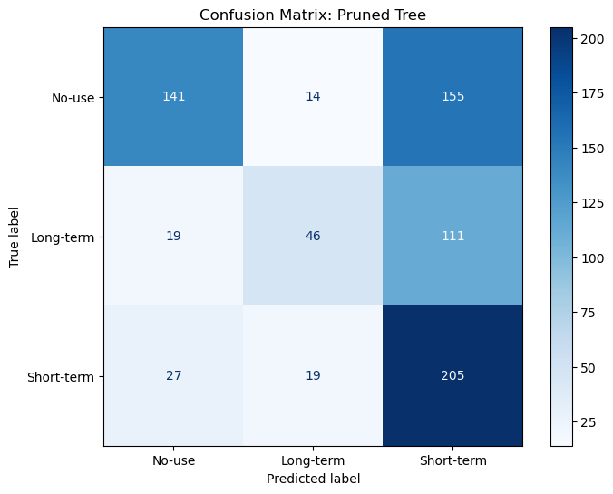
Figure 5
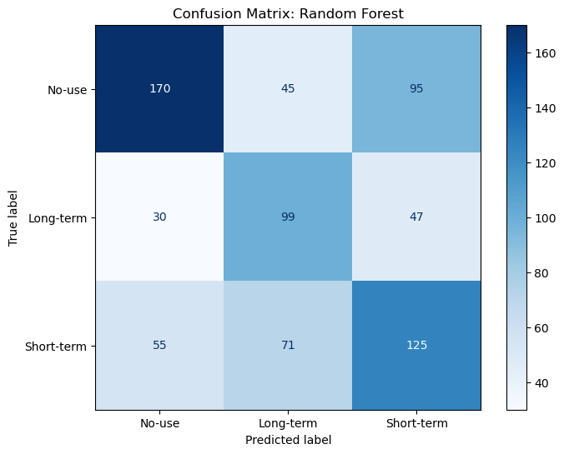
Figure 6
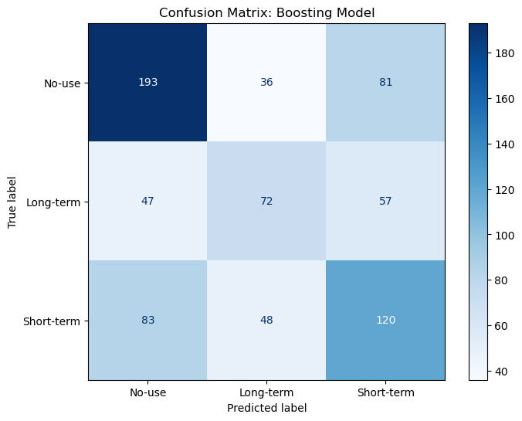

Figure 7
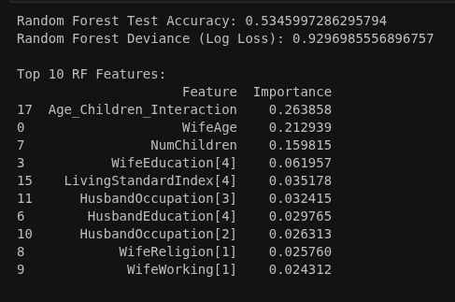

Figure 8
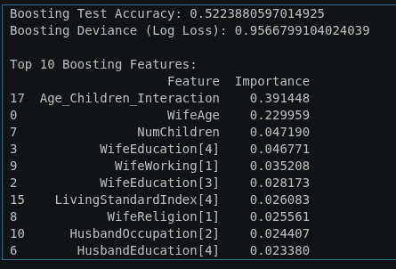

Figure 9
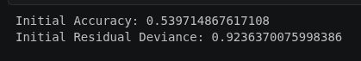

Figure 10


Figure 11
